Independent Reading Assignment
During Content Area Reading, you were expected to master all elements of plot, character, conflict, theme, and setting. In order to review this material and start English I on the right foot, please read Begging for Change, the second book following Money Hungry. As you read, complete the charts for each concept we have learned. This assignment is due on ________________ and will count as your first grade for the semester.
Table of Expectations
Begging for Change: Characterization Chart 3
For this step, trake the twelve primary characters for each phase of the text. You should include the description of the character type in terms of protagonist or antagonist, static or dynamic, flat or round, and major or minor. Additionally, you should provide three to five sentences justifying your claim.
Setting Analysis 5
Think about the manner in which the setting impacts the story as a whole. As you read, think about the primary setting details and track them on the included frayer chart. Be sure to include page numbers in order to have the text-based evidence you will need upon returning to class.
Begging for Change: Conflict Analysis 7
For this element, track the major conflict of the text and the minor conflicts whice result from the protagonist's primary conflict.
Plot Analysis: 9
Use the provided plot map to outline the major components in the plot of Begging for Change. Pay special attention to the inciting event and climax as you work. You should be able to justify how you know each of these represents the part of plot you suggest it represents. Include page numbers with your evidence.
SWBS Theme Analysis 11
For the final task, you are expected to complete a SWBS Summary of the ENTIRE text. From your summary, think about the topic or life lesson learned. Then, write a theme statement you could easily write an essay for if the need should arise.

Begging for Change: Characterization Chart
Character’s Name | Description * | Justification +
Character’s Name | Description * | Justification +

Setting Analysis

Begging for Change: Conflict Analysis
Use the following chart to analyze the various conflicts developed in the novel.
What is the primary conflict in the novel?

Who is involved?

Is it internal or external? Explain.

How is the conflict resolved?

What are some of the secondary conflicts in the novel? Remember, characters other than the main character can experience important conflicts. Identify one conflict for each provided character.

Character | Explain the conflict | How is it resolved?
Momma

Zora

Ja’nae

Mai

Miracle

Plot Analysis:
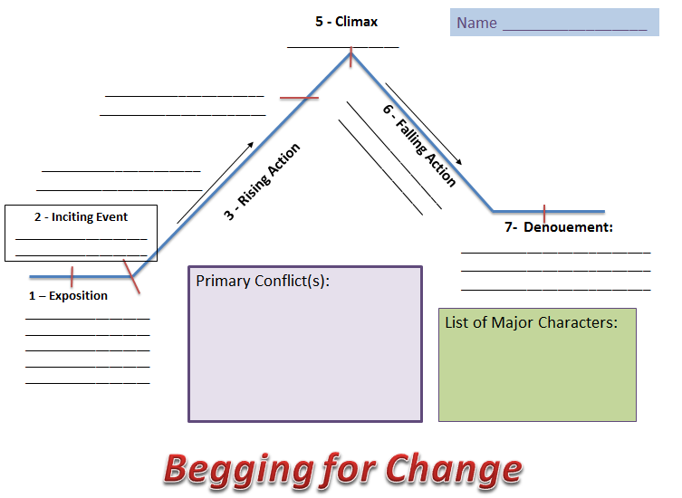

SWBS Theme Analysis
Directions: Use SWBS to create a theme statement. Remember to use thorough answers and complete sentences to best prepare for your theme statement.

Theme Statement:

Short Answer Questions

Directions: Answer the following questions thoughtfully. Questions 1-5 reflect on the previous learning which occurred during class while reading Money Hungry. You should answer these questions before reading Begging for Change. Questions are graded on a scale of 1-5 depending on the quality of response. Make sure all answers are written in complete sentence form. Additionally, if the question has multiple parts, make sure you have addressed all sections.
- Raspberry and her friends all want money for different reasons. Compare and contrast these reasons. Are they all equally important?

- Raspberry and her friends each seem to have their own share of problems. Zora’s parents are recently divorced, Ja’nae’s mother abandoned her, and Mai is embarrassed of her family. Do you relate to Raspberry or any of her friends? If so, which friend and why?

- Raspberry’s friends become tired of her money schemes, and begin to call her “greedy”. Do you really think she is selfish? What other words might you use to describe her instead?

- Although Raspberry and her mother do not have much, they have each other. What lesson does this teach you about family? What do you think about money after reading this story?

- Do you know of or have you seen anyone living in poverty? What are ways you could help those less fortunate? In what ways could growing up in poverty affect a teen’s life?

Directions: Answer the following questions thoughtfully. These questions reflect on topics covered in Begging for Change. You should answer these questions as you prepare for your story analysis of the text as a part of your Winter Reading. Questions are graded on a scale of 1-5 depending on the quality of response. Make sure all answers are written in complete sentence form. Additionally, if the question has multiple parts, make sure you have addressed all sections.

- Why does Rasberry steal Zora’s money? Do you think Zora should consider her a friend anymore? Why or why not? Would you be able to forgive Raspberry?

- Which adults in Rasberry’s life act as surrogate parents? How do adults other than your parents influence your own life? Can other people ever make up for a missing parent?

- Ms. Hill says, “We can make something sweet and good out of all the mess around us. If we want.” Do you agree with her? How does she try to accomplish this in her life? How could you?

- Would you ever write letters that you wouldn’t send? Why or why not? What is the significance of this action for Momma? What is the significance of this action to Raspberry?

- Do you agree with Rasberry that Ms. Hill brings on some of the grief in her life by digging into other people’s business? If you do, explain how. If not, why not?

- Rasberry says, “I’m gonna live in a big house, with four bathrooms, eight fireplaces, and a refrigerator so big it’ll have four doors on it.” What qualities about Rasberry make you believe this statement? What personality traits does Rasberry possess that will make her dreams come true? Are their any qualities she’ll have to overcome to succeed?

- Why doesn’t Zora tell the other girls about what Rasberry did? Would you have told them?

- Do you feel sorry for Rasberry when she gets her own money stolen? Why or why not?

- Why do you think Rasberry’s stealing escalates in this novel?

- Why does Sato accept the fact that Raspberry stole once from her friend? Do you think he would still be interested in her if she repeated the offense? Do you think this will affect Raspberry’s penchant for pilfering money? Why or why not? Would this be an important issue for you in a relationship? Why?

English I
Reading Accountability Form
During Content Area Reading, I was expected to master all elements of plot, character, conflict, theme, and setting. In order to review this material and start English I on the right foot, all students were expected to read Begging for Change and complete the charts for each concept learned during CAR. This assignment was due on ____________________ and counted as my first test grade for the semester. Below I have included my progress and plans for completion of this task prior to due date.

Task Component | Status (How much have I done?) | What is my plan for completion? | Teacher/student initial and date when turned in.
Reading Questions
Characterization Chart
Setting Analysis
Conflict Analysis
Plot Map
Theme Statement

