Cleveland Landmarks: Let’s Take A Virtual Tour: ELA

Objective: To evaluate Cleveland landmarks and create a visual presentation highlighting its’ historical and social significance and impact on the Greater Cleveland community.

Common Core Standards:

CCSS.ELA-LITERACY.RI.7.2
Determine two or more central ideas in a text and analyze their development over the course of the text; provide an objective summary of the text.

CCSS.ELA-LITERACY.RI.7.7
Compare and contrast a text to an audio, video, or multimedia version of the text, analyzing each medium's portrayal of the subject (e.g., how the delivery of a speech affects the impact of the words).

CCSS.ELA-LITERACY.W.7.6
Use technology, including the Internet, to produce and publish writing and link to and cite sources as well as to interact and collaborate with others, including linking to and citing sources.

CCSS.ELA-LITERACY.W.7.7
Conduct short research projects to answer a question, drawing on several sources and generating additional related, focused questions for further research and investigation

CCSS.ELA-LITERACY.W.7.8
Gather relevant information from multiple print and digital sources, using search terms effectively; assess the credibility and accuracy of each source; and quote or paraphrase the data and conclusions of others while avoiding plagiarism and following a standard format for citation.

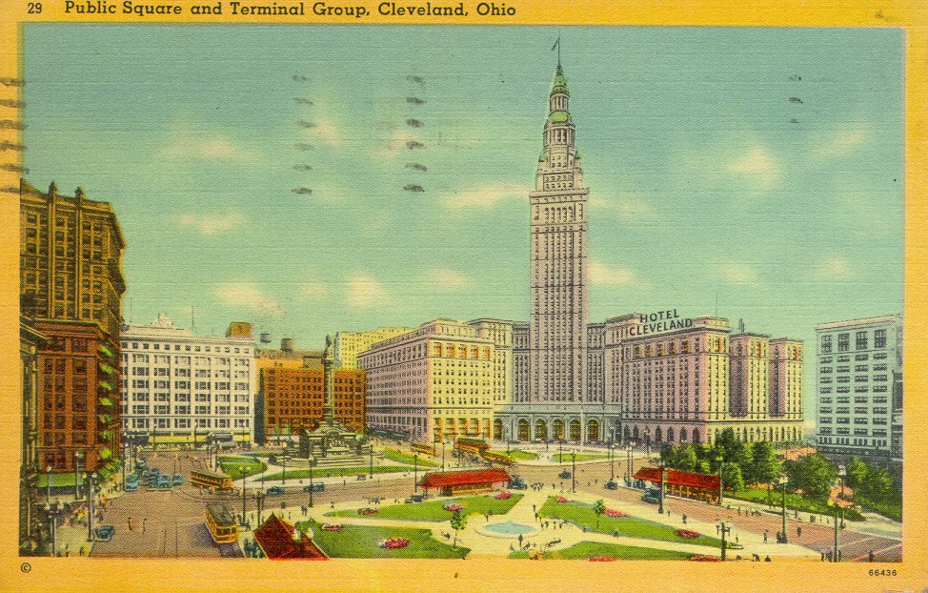 (Date) __________

Dear Parents,

Our English class is conducting research in the form of pictures, newspaper items, brochures, and the use of the internet to collect data for a class project. Each student will choose a local landmark or site/person and present an oral report and develop either a brochure or multimedia presentation. Research will be conducted at school and should be done at home as well. Library visits are encouraged. However, if you have additional information please feel free to share it with you child.

The students will be given a list of sites and landmarks to choose from for their research project. An outline of information about their chosen landmark or site will be used to create a multimedia presentation. Encourage your child to be creative!

This project will be graded on content, neatness, and presentation according to the Greater Cleveland Landmark or Historical Site/Person Score Sheet guidelines.

Your child has chosen __________________________________________________

Oral reports and projects will be due on __________________. There is a 10 point deduction each day the project is late.

We appreciate your help and cooperation with this exciting project.

I have read and understand the project listed above.

Signature: (student)________________________________________

(parent)_________________________________________

Cleveland Memory Project-Landmarks

1. The Alcazar _________________________________

2. Terminal Tower _________________________________

3. The Old Stone Church _________________________________

4. The Christmas Story House _________________________________

5. Cuyahoga River Fire _________________________________

6. Forest Hills Park(John D. Rockefeller) _____________________________

7. Rock & Roll Hall of Fame/Museum _______________________________

8. Millionaires’ Row _________________________________

9. Ohio City _________________________________

10. Lakeview Cemetery _________________________________

11. Paul Brown(pro football) _________________________________

12. Carl Stokes _________________________________

13. Elliott Ness _________________________________

14. Euclid Beach _________________________________

15. West Side Market _________________________________

16. Hough Riots _________________________________

17. Collinwood School Fire _________________________________

18. Lake Erie _________________________________
19. Moses Cleaveland _________________________________

20. Little Italy _________________________________

21. Severance Hall _________________________________

22. The Karamu House _________________________________

23. The Free Stamp _________________________________

24. Slavic Village _________________________________

25. St John’s Cathedral _________________________________

26. The Halle Building _________________________________

27. William Mather Ship _________________________________

28. Call & Post Newspaper _________________________________

29. Transportation Bridge _________________________________

30. Soldiers & Sailors Monument _________________________________

31. Bratenahl _________________________________

32. University Circle _________________________________

33. The Cleveland Grays Armory __________________________________

34. Squire’s Castle __________________________________

35. Cain Park __________________________________

36. Old Arcade ___________________________________

37. Higbee Department Store ___________________________________

38. Van Sweringen Brothers ___________________________________
Cleveland Landmarks: Let’s Take A Virtual Tour Due___________

Directions:

Create a visual presentation (Keynote or I-Movie) that identifies, evaluates and explains the historical and social significance of your assigned Cleveland landmark or person.

Students are to demonstrate their knowledge of a specific Greater Cleveland area landmark, site or person by creating various presentations showing why these landmarks/ sites/ people are known to people everywhere.

This presentation should include:

- Pictures with captions or narration(slideshow with your movie or garage band) and other types of items or facts associated or related to the local site of interest or person.
- Cite information that justifies its’ historical significance. Why is it important to our area? Describe or illustrate in detail contributions of the landmark ,site or person and their contribution to local history.
- Cite information that explains its’ social significance.
- Include amazing facts about the landmark or person.
- Current status of landmark/person.
- Create a slideshow with researched information and present to classmates, other classes, and parents.

Sites that might be helpful:
http://www.clevelandmemory.org/

http://www.cityprowl.com/ a collection of recorded walking tours of the city that can be downloaded free

http://ech.cwru.edu/index.html The Encyclopedia of Cleveland History

Cleveland Public Library System

Google images of Cleveland

Check to see if your topic has a website

Additional Notes:________________________________________________________________

________________________________________________________________________________

________________________________________________________________________________

________________________________________________________________________________

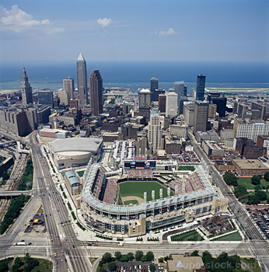
KWL: My Cleveland Landmark or Person of Interest
________________________
Use this chart during your study of your landmark, site or person. First write what you know about your landmark or site. Then write what you would like to know about it. At the end of your study write the most important things that you learned.
What I know about this  landmark or site | What I would like to know about this landmark or site | What I have learned about this landmark or site

Greater Cleveland Landmark/Historical Site or Person Score Sheet

Oral Report and Project
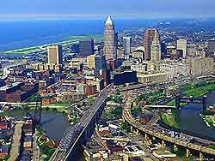

Name_____________________________________ Date__________

Oral Report

1. Student completed report outline. (25 points) _______

2. Student used outline to create report. (25 points) _______

3. Information was researched and accurate. (25 points) _______

4. Information was presented clear and smooth. (25points) _______

Total points _______

Letter Grade _______

****************************************************************

Final Project

1. Student followed directions for completing project. (25 points) _______

2. Facts of chosen landmark or site/person were correctly presented.
(25 points) _______

3. Project was neat, typed information was correct and student was
creative when selecting multimedia project materials. (25 points) _______

4. Project was turned in on time. (25 points) _______

Total points ________

The Greater Cleveland Area Landmark or Historical Site/Person

Name ______________________________

- My chosen landmark or site/person

___________________________________________

- Historical facts about my landmark or site_______

- General facts about my landmark or site/person

4. What is special about this landmark or site/person? Why?

- How can I contribute or help preserve the continuous success or memory of my chosen site/person?

Resources used to locate this information.

