Figurative language
Unit

ELA-TIMS

Name:
Checklist

Similies and Metaphors (30)__________

Personification & Onomatopoeia (10)_________

Hyperbole & Alliteration (30) _________

Imagery definition(3) & Text(54) Imagery Questions(8) ________

Idioms (30) _________

Clichés( 10)__________

Irony (5)_________

Final Project(65)__________ Project due ________

Total points _______________/215 points

FIGURATIVE LANGUAGE

Directions:

Step 1: Listen to each clip, and replay as needed.

Step 2: On your paper, highlight the Similes(1 color) and/or
Metaphor (another color) that you heard.

Step 3: Analyze & decide what comparison the simile/
Metaphor makes in the lyrics.

Step 4: Explain what the simile/metaphor mean to you.

Step 5: Discuss with class as directed by the teacher.

Metaphor:

Simile:

Excerpt from "Firework" by Katy Perry
Do you ever feel like a plastic bag
Drifting through the wind, wanting to start again?
Do you ever feel, feel so paper thin
Like a house of cards, one blow from caving in?
Do you ever feel already buried deep six feet under?
Screams but no one seems to hear a thing
Do you know that there's still a chance for you
'Cause there's a spark in you?
You just gotta ignite the light and let it shine
Just own the night like the 4th of July
'Cause, baby, you're a firework
Come on, show 'em what you're worth
Make 'em go, "Oh, oh, oh"
As you shoot across the sky-y-y
Baby, you're a firework
Come on, let your colors burst
Make 'em go, "Oh, oh, oh"
You're gonna leave 'em falling down oh, oh

You don't have to feel like a wasted space
You're original, cannot be replaced
If you only knew what the future holds
After a hurricane comes a rainbow
Maybe a reason why all the doors are closed
So you could open one that leads you to the perfect road
Like a lightning bolt, your heart will glow
And when it's time you'll know
You just gotta ignite the light and let it shine
Just own the night like the 4th of July

Analysis: _________________________________________________________

_________________________________________________________

_________________________________________________________

Rascal Flatts - Life Is A Highway Lyrics | MetroLyrics

Life is a highway, I wanna ride it
All night long
If you're going my way, I wanna drive it
All night long

Analysis: _________________________________________________________

_________________________________________________________

_________________________________________________________

Britney Spears - Circus Lyrics | MetroLyrics
All eyes on me in the center of the ring just like a circus
When I crack that whip, everybody gon' trip just like a circus
Don't stand there watching me, follow me, show me what you can do
Everybody let go, we can make a dance floor just like a circus ahhhhha
Analysis:
_________________________________________________________

_________________________________________________________

_________________________________________________________

_________________________________________________________

Kanye West - Heartless Lyrics | MetroLyrics
How could you be so heartless?
How could you be so cold?
As the winter wind when it breeze yo
Just remember that you talkin' to me though
You need to watch the way you talkin' to me though
Analysis:
_________________________________________________________

_________________________________________________________

_________________________________________________________
_________________________________________________________
Katy Perry - Hot And Cold Lyrics | MetroLyrics
You change your mind
Like a girl changes clothes

_________________________________________________________

_________________________________________________________

_________________________________________________________

Hyperbole-________________________________________________
_________________________________________________________

Personification-___________________________________________
________________________________________________________

Onomatopoeia ________________________________________________

_____________________________________________________________

Alliteration-___________________________________________________

_____________________________________________________________

Name:_________________________________________________
Pick Out The PERSONIFICATION or ONOMATOPOEIA in the sentence

- The rain kissed my cheeks as it fell.

- The video camera observed the whole scene.

- The breaks squeaked as the car came to a stop.

- The car engine coughed and sputtered when it started during the blizzard.

- The boy moved his chair, squeak!

- The dishes clattered as they fell on the floor.

- The wind sang her mournful song through the falling leaves.

Hyperbole practice:
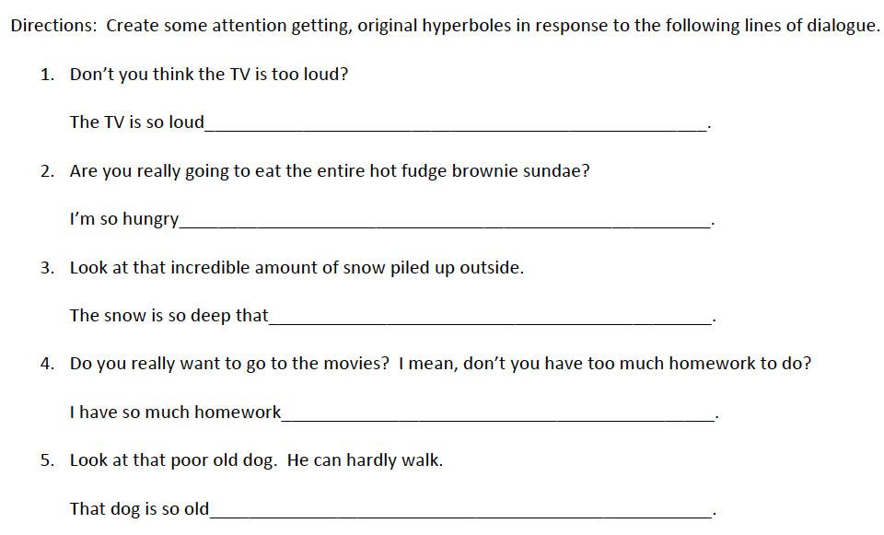

Highlight all Hyperbole.(yellow) Highlight all Alliteration (light blue)
Sarah Cynthia Sylvia Stout Would Not Take The Garbage Out
Sarah Cynthia Sylvia Stout
Would not take the garbage out!
She’d scour the pots and scrape the pans,
Candy the yams and spice the hams,
And though her daddy would scream and shout,
She simply would not take the garbage out.
And so it piled up to the ceilings:
Coffee grounds, potato peelings,
Brown bananas, rotten peas,
Chunks of sour cottage cheese.
It filled the can, it covered the floor,
It cracked the window, it blocked the door
With bacon rinds and chicken bones,
Drippy ends of ice cream cones,
Prune pits, peach pits, orange peel,
Gloppy glumps of cold oatmeal,
Pizza crests and withered greens,
Soggy beans and tangerines,
Crusts of black burned buttered toast,
Gristly bits of beefy roasts. . .
The garbage rolled down the hall,
It raised the roof, it broke the wall. . .
Greasy napkins, cookie crumbs,
Globs of gooey bubble gum,
Cellophane from green baloney,
Rubbery blubbery macaroni,
Peanut butter, caked and dry,
Curdled milk and crusts of pie,
Moldy melons, dried up mustard,
Eggshells mixed with lemon custard,
Cold french fries and rancid meat,
Yellow lumps of Cream of Wheat.
At last the garbage reached so high
That finally it touched the sky.
And all the neighbors moved away,
And none of her friends would come out to play.
And finally Sarah Cynthia Stout said,
“OK, I’ll take the garbage out!”
But then, of course, it was too late. . .
The garbage reached across the state,
From New York to the Golden Gate.
And there, in the garbage she did hate,
Poor Sarah met an awful fate,
That I cannot right now relate
Because the hour is much too late.
But children, remember Sarah Stout
And always take the garbage out!
- ~Shel Silverstein
IMAGERY

DEFINE:_____________________________________________________________

___________________________________________________________________

Color-code the imagery words/phrases in the text below. Use the colors indicated.

The hot July sun beat relentlessly down, casting an orange glare over the farm buildings, the fields, the pond. Even the usually cool green willows bordering the pond hung wilted and dry. Our sun-baked backs ached for relief. We quickly pulled off our sweaty clothes and plunged into the pond, but the tepid water only stifled us and we soon climbed onto the brown, dusty bank. Our parched throats longed for something cool--a strawberry ice, a tall frosted glass of lemonade.
We pulled on our clothes, crackling underbrush, the sharp briars pulling at our damp jeans, until we reached the watermelon patch. As we began to cut open the nearest melon, we could smell the pungent skin mingling with the dusty odor of the dry earth. Suddenly, the melon gave way with a crack, revealing the deep, pink sweetness inside.

Sight Sound Touch Taste Smell
(Red) (Orange) (Yellow) (Green) (Blue)

Imagery Check: Indicate which of the 5 senses each sentence or phrase represents: Sight-Sound-Touch-Taste_Smell

1. He was a shaggy, thick-fellow; his coat was greasy about the lapels and pockets, and his hand splayed over the cane’s crook with a futile sort of clinging. __________

2. A ginger cat, very tall and thin streaked glass, flashing with sunlight. __________

3. Strong melodious songs crackling splinters of glass and dried putty. __________

4. Soft shapes...inside the hard bodies. ________

5. Juicy and tart ________

6. Rolling rumble and crash_________

7. Leaves were green and stirring. Berries, luster-glossed. ________

8. What is Poetry? Who knows? Not a rose, but the scent of a rose. ________

Idioms:_____________________________________

___________________________________________

Idiom Assignment:

- Select an Idiom from the list….
- Create a poster of the literal meaning of your idiom….. (computer or drawn) SMALL ONLY
- Include:
  - Title of the idiom
(ex:It’s Raining Cats and Dogs)
  - What the idiom means
(ex:It is raining very hard)
  - Sentence using the idiom
  - Your name

All ears
Ants in your pants
Arm and a leg
At the end of your rope
Axe to grind
Back to the drawing board
Barking up the wrong tree
Between the lines
Blood out of a stone
Blow your stack
Bone to pick
Bull in a China shop
By the skin of your teeth
Can of worms
Cold feet
Crash a party
Cry your eyes out
Don’t wash your dirty laundry in public
Down in the dumps
Eagle eyes
Elephant in the room
Feeling Blue
Fifth wheel
Fish out of water
Go round in circles
Grab the bull by its horns
Head is in the clouds
Heart of gold
Hook, line, and sinker
Horse of a different color
In the doghouse
It cost an arm and a leg
Jump the gun
Like a fish needs a bicycle
Make waves
Money talks
Opening a can of worms
Out on a limb
Piece of cake
Pull someone's leg
Pull your weight
Rock the boat
See the light
Stick out like a sore thumb
Tall story
Thin-skinned
Thrilled to bits
Walk on eggshells
Written all over your face
You can say that again

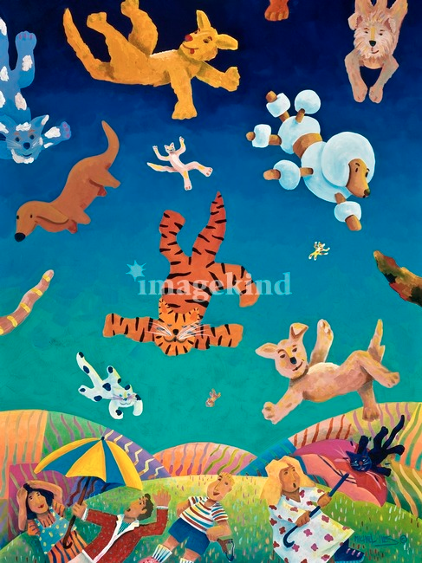

ClichE

Define:____________________________________

__________________________________________

Compose a list of five (5) clichés that middle school students use.

1._______________________________________

2._______________________________________

3.________________________________________

4.________________________________________

5.________________________________________

IRONY

Verbal____________________________________

Situational__________________________________

__________________________________________

Dramatic___________________________________

__________________________________________

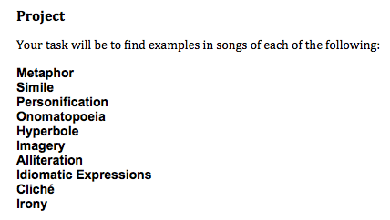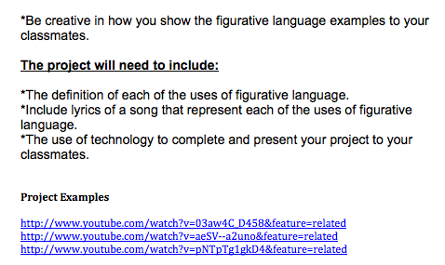

Be Sure to Identify each example thoroughly.

Final project Figurative Language Rubric
Name_____________________________ Score______/65
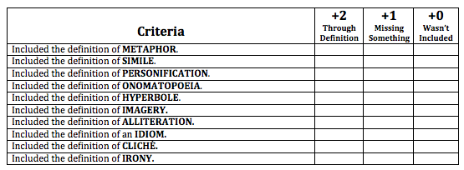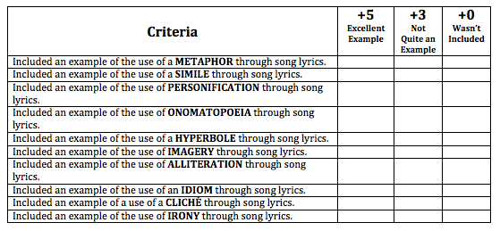
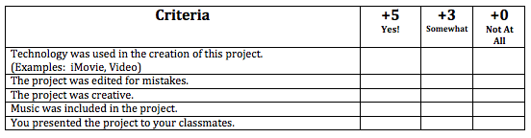

Imagery Check
Sight, Smell, Touch, Taste, Sound

1. He was a shaggy, thick-fellow; his coat was greasy about the lapels and pockets, and his hand splayed over the cane’s crook with a futile sort of clinging. _______________

2. A ginger cat, very tall and thin streaked glass, flashing with sunlight. _____________________

3. Strong melodious songs crackling splinters of glass and dried putty
______________________

4. Soft shapes...inside the hard bodies ___________________

5. Juicy and tart ________________________

6. Rolling rumble and crash_________________________

7. Leaves were green and stirring. Berries, luster-glossed.________________

8. What is Poetry? Who knows? Not a rose, but the scent of a rose.

____________________

Notes:

Common Core Standards:
7.RL.4 Determine the meaning of words and phrases as they are used in a text, including figurative and connotative meanings; analyze the impact of rhymes and other repetitions of sounds (e.g., alliteration) on a specific verse or stanza of a poem or section of a story or drama.
7. SL.3 Delineate a speaker’s argument and specific claims, evaluating the soundness of the reasoning and the relevance and sufficiency of the evidence.
7.SL.5 Include multimedia components and visual displays in presentations to clarify claims and findings and emphasize salient points.
7.l.2 Demonstrate command of the conventions of standard English capitalization, punctuation, and spelling when writing.
7.L.5 Demonstrate understanding of figurative language, word relationships, and nuances in word meanings.

